**SHOPPING MANAGEMENT SYSTEM**

Project Report On

Submitted in fulfillment of the requirements of the degree of

**Diploma in Information Technology**

By:

|  |  |
| --- | --- |
| HARSHIL | 21171371012 |
| PARTH | 21171371028 |

Under the Guidance of

Prof. Anso B Christian



Submitted to,

Department of Information Technology

B. S. Patel Polytechnic

Ganpat University, Ganpat Vidyanagar – 384012.

(Month - 2023)

CERTIFICATE

* This is to certify that Project work of course Project -1 (1CE2506) embodied in this semester entitled “Hotel Management System” was carried out by following students studying at B. S. Patel Polytechnic, Ganpat University for partial fulfillment of degree of Diploma Engineering in Computer Engineering. This Project work has been carried out under my supervision and is up to my satisfaction.

|  |  |
| --- | --- |
| HARSHIL | 21171371012 |
| PARTH | 21171371028 |

Examiners

Place:

Date:

Head of Department

Guide/Supervisor (s)

**Declaration**

* I declare that this written submission represents my ideas in my own words and where others’ ideas or words have been included, I have adequately cited and referenced the original sources. I also declare that I have adhered to all principles of academic honesty and integrity and have not misrepresented or fabricated or falsified any idea/data/fact/source in my submission. I understand that any violation of the above will be cause for disciplinary action by the Institute and can also evoke penal action from the sources which have thus not been properly cited or from whom proper permission has not been taken when needed.

**Acknowledgements**

* We would first like to thank my thesis Guide Prof. Pratik B. Mewada Department of Computer Engineering at B. S. Patel Polytechnic, Ganpat University. The door to Professor’s office was always open whenever we ran into a trouble spot or had a question about my/our project or writing. He has always showed enough gratitude and patience towards us. He consistently allowed this work to be our own work, but steered us in the right direction whenever he thought we needed.
* We would also like to thank the experts who were involved in the validation survey for this project specially our HOD Prof. B N Patel and the experts who participated. Without their passionate participation and validation, survey could not have been successfully conducted. we are also thankful to B. S. Patel Polytechnic, Ganpat University for providing us the platform to grow and explores our knowledge without any hindrance.
* Finally, We must express our very profound gratitude to our parents and colleague for providing us with unfailing support and continuous encouragement throughout our study and through the process of researching and writing this report. This accomplishment would not have been possible without them.

|  |  |
| --- | --- |
| HARSHIL | 21171371012 |
| PARTH | 21171371028 |

|  |  |
| --- | --- |
| 1. **PROBLEM IDENTIFICATION, DEFINITION & MODIFICATION** | **PAGE No.** |
| 1.1 ABSTRACT OF PROJECT AND OVERVIEW OF PROBLEM |  |
| 1.2 EXISTING SYSTEM |  |
| 1.3 PROJECT PROFILE |  |
| 1.4 TECHNOLOGY OVERVIEW |  |
| 1. **SYSTEM REQUIREMENT SPECIFICATION** |  |
| 2.1 REQUIREMENT GATHERING AND ANALYSIS |  |
| 2.2 SOFTWARE REQUIREMENT SPECIFICATION |  |
| 2.3 FESIBILITY STUDY |  |
| 1. **PROBLEM SOLUTION OUTLINE** |  |
| 3.1 MODULES DESCRIPTION |  |
| 3.2 DATA DICTIONARY |  |
| 3.3 ENTITY RELATIONSHIP DIAGRAM |  |
| 3.4 FLOW CHART |  |
| 3.5 DATAFLOW DIAGRAM |  |
| 3.6 USECASE DIAGRAM |  |
| 1. **CONCLUSION FUTURE DEVELOPMENT** |  |
| 4.1 CONCLUSION |  |
| 4.2 FUTURE DEVELOPMENT |  |
| 1. **REFERENCES** |  |

**TABLE OF CONTENTS**

|  |  |  |
| --- | --- | --- |
| **Figure No.** | **Title of Figure** | **Page No.** |
| Figure 2.1 |  |  |
| Figure 2.2 |  |  |
| Figure 3.1 |  |  |
| Figure 3.2 |  |  |
| Figure 3.3 |  |  |
| Figure 3.4 |  |  |
| Figure 3.5 |  |  |
| Figure 3.6 |  |  |
| Figure 3.7 |  |  |
| Figure 3.8 |  |  |
| Figure 3.9 |  |  |
| Figure 3.10 |  |  |

**LIST OF FIGURES**

|  |  |  |
| --- | --- | --- |
| **Figure No.** | **Title of Figure** | **Page No.** |
| Figure 2.1 |  |  |
| Figure 2.2 |  |  |
| Figure 3.1 |  |  |
| Figure 3.2 |  |  |
| Figure 3.3 |  |  |
| Figure 3.4 |  |  |
| Figure 3.5 |  |  |
| Figure 3.6 |  |  |
| Figure 3.7 |  |  |
| Figure 3.8 |  |  |
| Figure 3.9 |  |  |
| Figure 3.10 |  |  |

**LIST OF TABLES**

**CHAPTER: 1**

**PROBLEM IDENTIFICATION, DEFINATION & MODIFICATION**

**1.1 ABSTRACT**

Welcome to an exciting online shopping clothes and shoes web app that brings the world of fashion and footwear right to your fingertips! This innovative platform offers a diverse and trendy collection of clothing and shoes to cater to all styles and preferences. Navigating the app is a breeze with its user-friendly design, allowing you to effortlessly browse through the latest trends and find your perfect outfit or pair of shoes. With personalized recommendations, the app ensures that you discover new and exciting fashion pieces that match your unique taste. The web app prioritizes your security by providing safe and secure transactions, while also offering various payment options for added convenience. Quick and reliable delivery services ensure that your fashion finds reach your doorstep promptly. Embrace the fusion of technology and style with this delightful online shopping clothes and shoes web app, making your virtual shopping experience enjoyable, convenient, and unforgettable. It's time to explore a whole new world of fashion and footwear from the comfort of your own device!

**1.2 EXISTING SYSTEM**

**1.2.1 AMAZON**

The Amazon shopping app is a leading e-commerce platform offering a vast selection of products, including clothes and shoes, from various brands. But the major problem with this site is there are limited warehouses to store items/product.

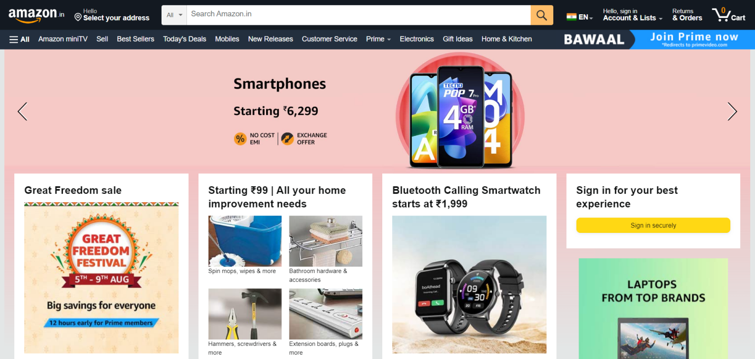

They do not give customer support. There is one more major issue with this site that you can add only limited products in your cart. You can pay for your product online but you must have amazon pay account

**Features :**

1. Wish list the product
2. Order tracking
3. Pay online
4. COD (Case On Delivery)

**1.2.2 ZARA**

The Zara website is the online platform for the popular fashion retailer Zara, offering a wide range of trendy and affordable clothing options. The major problem with this site is that it’s take much time to load whole website.



There are many bugs in this website (as per 07/2023). They are mostly focused on women beauty products and clothing.

**Features :**

1. Wishlist the product
2. Order tracking
3. Multiple payment options
4. Size guide
5. International shopping

**1.2.3 ZUDIO**

The Zudio site suffers from a cluttered and outdated design, making it challenging for users to navigate and find the products they are looking for. The Zudio site has a confusing layout, making it hard to find what you want. It loads slowly and sometimes doesn't work properly, making the user’s experience frustrating.



**Features :**

1. Wishlist the product
2. Multiple payment methods
3. Online-Offline integration
4. Physical stores
5. Simplified design of website
6. User friendly interface

**1.2.4 NIKE**

A potential disadvantage of Nike shoes is that some consumers have reported issues with durability.This can be a concern for those looking for long-lasting footwear, especially if they engage in rigorous activities. It's essential to research specific models and read reviews to ensure you're choosing a Nike shoe that aligns with your durability expectations.

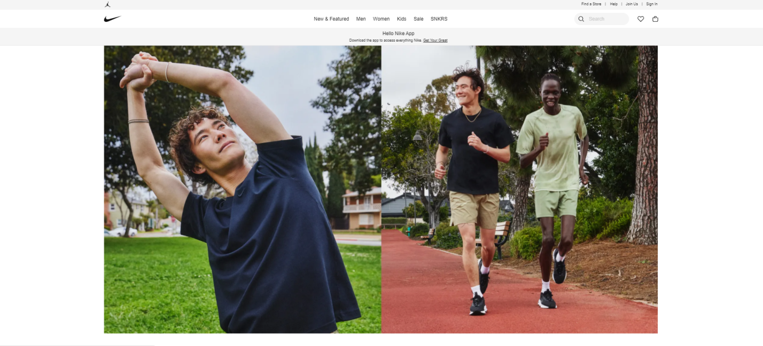

**Features :**

1. Wishlist the product
2. Popular brands showcase distinct uniqueness.
3. Pay online
4. Cash on delivery

**1.2.5 AJIO**

Some users might find the website's navigation and layout less intuitive or user-friendly. Like any online platform, Ajio might occasionally experience technical issues, affecting the shopping experience. Some customers may have experienced issues with customer service response times or problem resolution. The process for returns and refunds might not always be as smooth as desired. There could be instances of delayed or incorrect deliveries, impacting customer satisfaction.

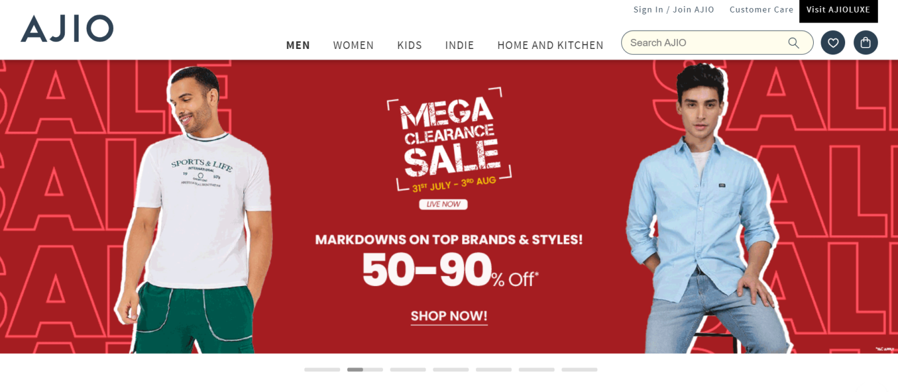

**Features :**

1. Wishlist the product

1. Popular brands showcase distinct uniqueness.
2. Pay online
3. Cash on delivery

**1.2.6 MEESHO**

The app might have a narrower selection compared to larger e-commerce platforms. There could be occasional delivery delays or issues due to the decentralized nature of the platform. Some users might face challenges with customer service response times or issue resolution. The process for returns and refunds might be less streamlined compared to established e-commerce platforms. Like any app, Meesho's performance might occasionally suffer from technical glitches or bugs. Users might be concerned about payment security when dealing with individual sellers.



**Features :**

1. Online payment
2. Order Tracking
3. Use friendly interface

**1.2.7 MYNTRA**

Myntra, like any other e-commerce platform, had certain disadvantages that users might have experienced. Keep in mind that these disadvantages might have changed or evolved since then. H ere are some potential disadvantages associated with Myntra

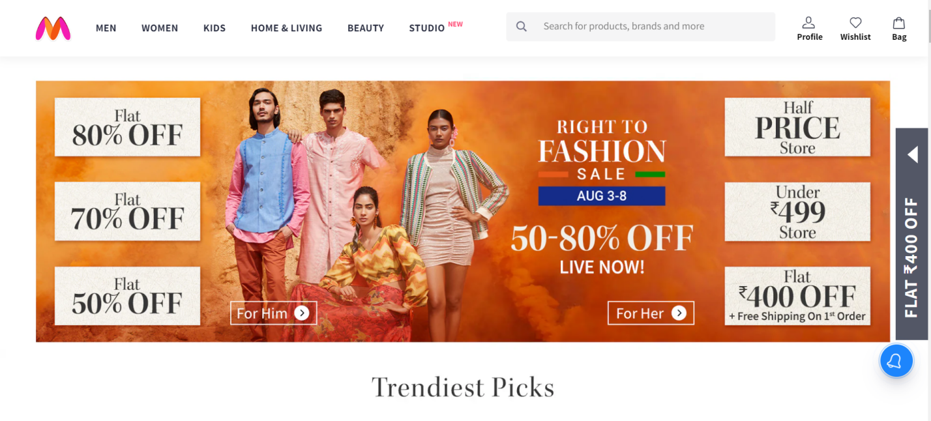

**Features :**

1. **Brand Collaborations**
2. **Myntra Insider Loyalty Program**
3. **Customer Reviews and Ratings**
4. **Size Guides and Fit Predictor**

**1.2.8 FLIPKART**

Flipkart is one of the largest e-commerce platforms in India. While it offers various advantages, there are also certain disadvantages associated with using Flipkart. Please note that these disadvantages might have changed or evolved since then. Here are some potential disadvantages of Flipkart

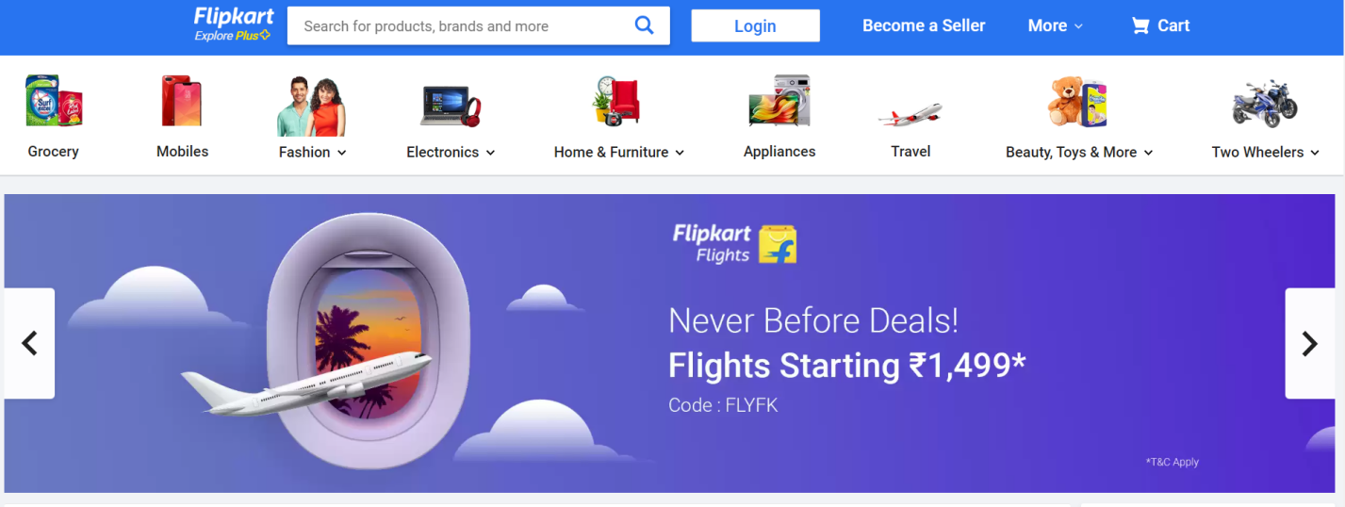

**Features**

1. **Smart Search and Recommendations**
2. **User-Friendly Interface**
3. **Secure Payment Options**
4. **Product Comparisons**
5. **Flipkart SuperCoin**

**1.2.8 TATACLIQ**

Similar to other online marketplaces, Tata Cliq allows third-party sellers to list products. Some customers might face concerns about product quality, authenticity, and customer service from certain sellers.The performance of the Tata Cliq mobile app might vary based on device compatibility, potentially causing issues for some user

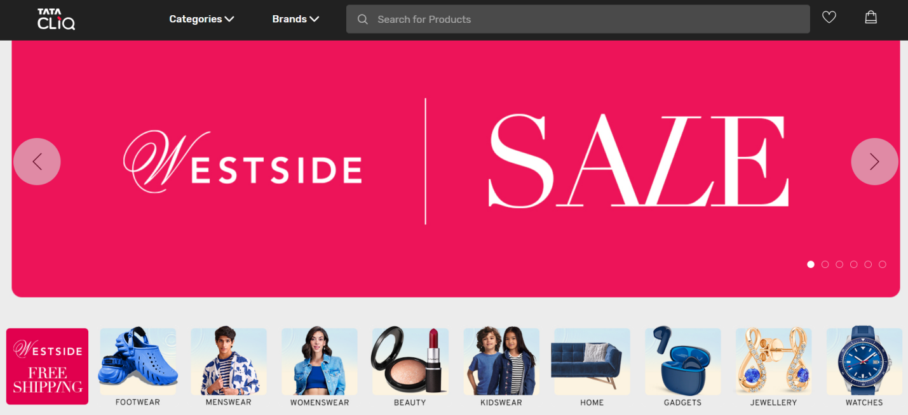

**Features**

1. **Cliq and Collect**
2. **Track Order Status**
3. **Tata Cliq Ten-Ten Sale**
4. **Same-Day Delivery**

**1.2.9 EBAY**

eBay is an online marketplace that connects buyers and sellers for various products and services. While eBay has numerous advantages, there are also some potential disadvantages associated with using the platform. Keep in mind that these disadvantages might have evolved or changed since then. Here are some common disadvantages of eBay

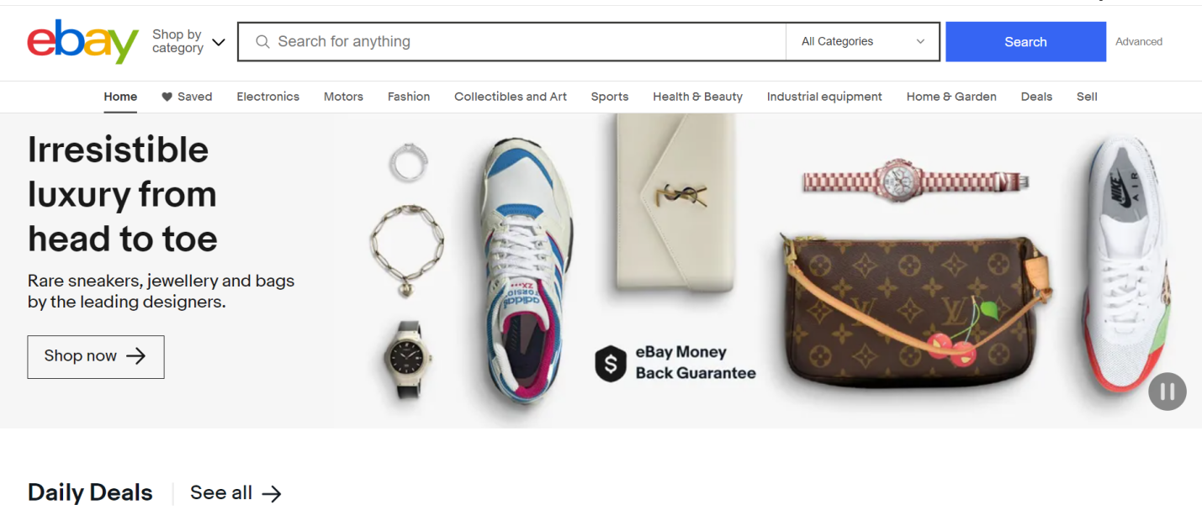

**Features**

1. **eBay for Charity**
2. **Bulk Listing Tools**
3. **Global Shipping Program**
4. **eBay Money Back Guarantee**

**1.2.10 ASOS**

ASOS offers a wide range of products from different brands, and the quality of items can vary. This can lead to difficulties in choosing the correct size, and customers might need to rely on user reviews or consult size guides.

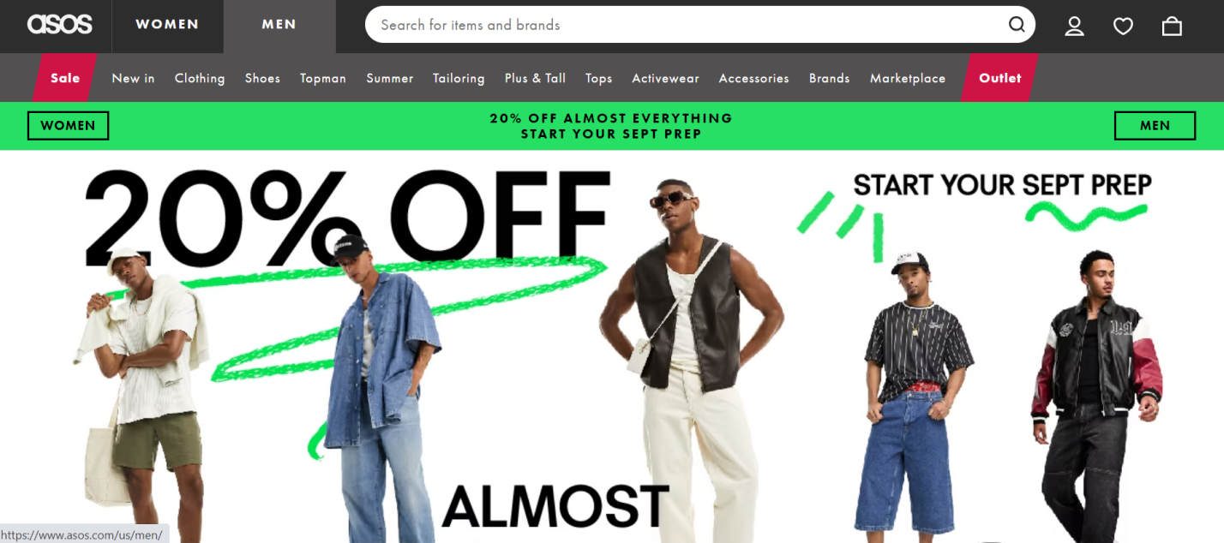

**Features**

1. Customer Service
2. Express Delivery Options
3. Outlet and Sale Sections
4. ASOS Marketplace

**CHAPTER : 2**

**SYSTEM REQUIREMENT SPECIFICATION**

**2.1 REQUIREMENT GATHERING AND ANALYSIS**

**1:-User Registration and Authentication**

**2:-Product Listings.**

**3:-Shopping Cart.**

**4:- Checkout Process.**

**5:- Payment Integration.**

**6:- Order Management.**

**7:- Search and Filters.**

**8:- Responsive Design.**

**9:- Security Measures.**

**10:- Contact Information.**

**2.2 SOFTWARE REQUIREMENT:**

**1:- Team Expertise:**

**2:-Project Requirements**:

In the **BRAVO Shoe & Clothing Online Shop**,

Are added additional Some **features like** :-

1. Easy Interface to **Easily Understand** The **UI INTERFACE**.

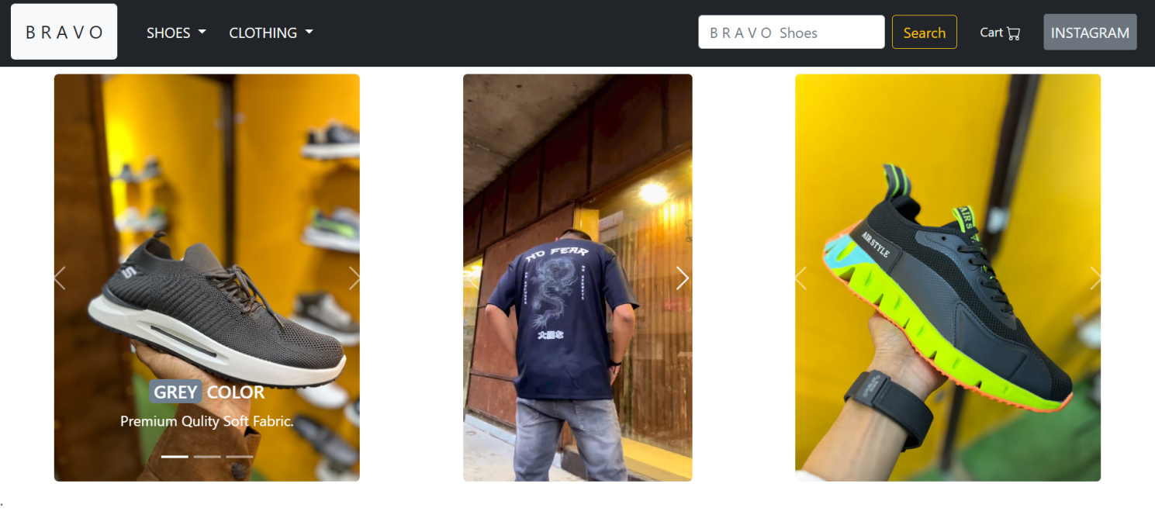

1. **LOGIN** Option

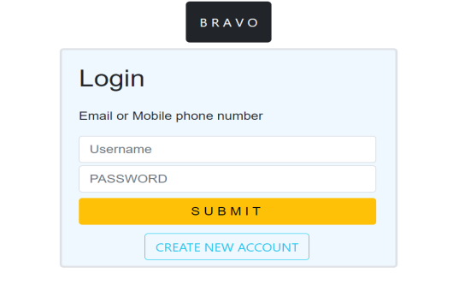

1. **SIGNING** Option

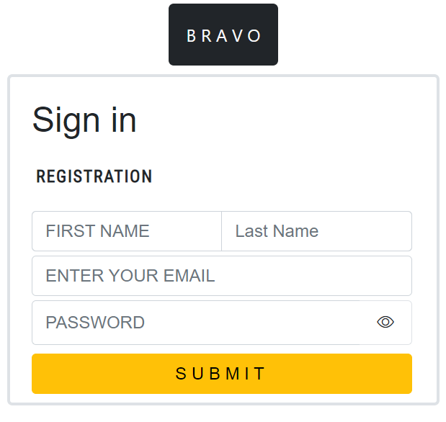

1. **CART** Option.

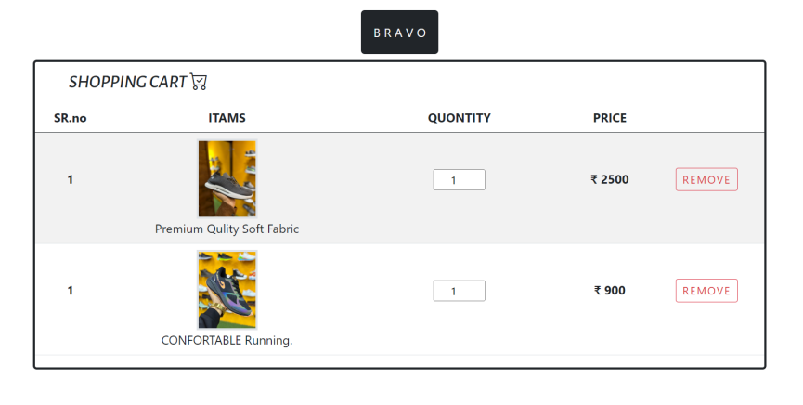

1. **SEARCH BAAR** Option.



1. Add **LOGOUT** Option
2. Add **SOCIAL MEADIA** Page
3. All Are **The Option** are **Added in NAV bar** (In **Header**).



1. USER ARE **EASILY ADD TO CART** AND **PLACE THE ORDER AT A TIME**.

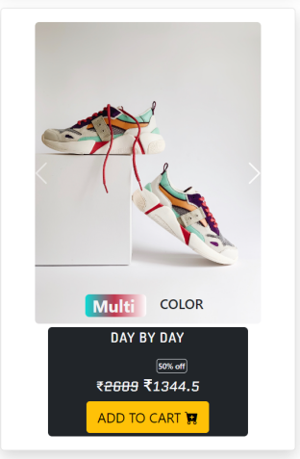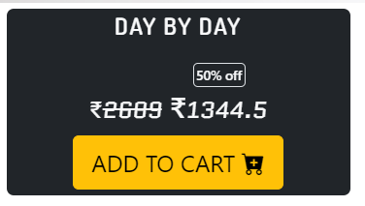

1. USER ARE ALL **MODIFICATION** **STORE** IN THE **DATABASE** WITH **THAIR EMAIL.**
2. USER CAN ‘**REMOVE**’ CART ARE THEY SELECTED AND ‘**ADD**’ ALSO and IT’S **DAIRECLY AFFACT ON** THE USER **DATABASE**.





1. In BRAVO Shoe & Clothing Online Shop in **Website** we are Used **languages and frameworks.**

**<HTML>.**

**PHP.**

**CSS.**

**JAVASCRIPT.**

**MYSQL.**

**BOOTSTRAP.**

1. **Added FOOTER** And **All are** the **information** are Show **in footer**.

**3:-Community and Documentation**: A strong community and comprehensive documentation can make the development process smoother, as you'll find answers to common issues and guidance on best practices.

**4:-Scalability**: in future we will be able to expand our business to further products such eye-ware , grooming accessories , watches , etc. We will also make an application for our website. We will also automate some workflow.

**5:-Ecosystem**: we will make a system which reward our customers for buying product from our website, which will in return increase the website traffic and the sales we make, which will help us further expend our business.

**6:-Security**: security is this top most priority in our website, we value our customers data and it’s security thus we will use a framework and database, which have high security in turn making our website harder to breach.

User framework with good security.

User powerful database.

We will use moderators for routine security checkup.

**Introduction**: In Their Project We are designed A UI To Attract User And We Pinned High Discounted Items top on the page.

**Market Analysis**: Basically Selling **SHOES** and **CLOTHS**

are the First Approach of Developer.

We have Contact Retailer & Wholesaler then After selling Their product we make Commition On At the time.

**Competitor Analysis:**

To the competitive business to hard to beat because that we are make Their product in Our Website & We are Sell the Particular faithful Retailer & Wholesaler .

We are Sell other Websites Discounted Items its profit for their website and maybe the Help to grow up Our Project and support our website

Another business are approach to our website take my item to your website….

**Business Model**:

We are sale in a minimum of the amount product to the save and afford The items And we are sale High Discounted Product to the costumer.

we no need to manage products in whorehouse.

We direct deal seller to Costumer.

**Technology and Development**:

1. Specify the technology stack required for website development (e.g., programming languages, CMS, e-commerce platform).
2. Evaluate the feasibility of developing the website in-house vs. outsourcing.
3. Consider the user interface (UI) and user experience (UX) design to ensure ease of navigation and engagement.
4. **Financial Analysis**:
5. Estimate startup costs, including website development, design, hosting, domain registration, and initial marketing efforts.
6. Create a detailed financial projection for at least the first year, including revenue, expenses, and profitability.
7. Calculate the break-even point and assess the time to reach profitability.

**legal and Regulatory Considerations:**

Identify legal requirements for operating an e-commerce website in your jurisdiction (business licenses, taxes, data protection).

Address compliance with online consumer protection laws and regulations.

**Marketing and Promotion:**

Develop a comprehensive marketing strategy to drive traffic and sales.

Plan digital marketing activities such as search engine optimization (SEO), pay-per-click (PPC) advertising, social media marketing, and influence collaborations.

Estimate marketing expenses and expected return on investment (ROI).

**Logistics and Operations:--**

Outline the order processing workflow, inventory management, and shipping logistics.

Consider partnerships with third-party logistics (3PL) providers for warehousing and delivery.

Evaluate the feasibility of offering various shipping options and tracking services.

**Customer Support:**

Define your customer service strategy, including response times, communication channels, and resolution processes.

Determine how you'll handle customer inquiries, complaints, returns, and refunds.

**Risk Assessment:**

Identify potential risks such as technical glitches, security breaches, supply chain disruptions, and changing market trends.

Develop contingency plans and risk mitigation strategies.

Conclusion and Recommendation:

Summarize the findings of the feasibility study.

Provide a clear recommendation on whether to proceed with the online shopping website project.

If the recommendation is positive, outline the next steps, timeline, and resource requirements for development and launch.

Appendices:

Include supporting documents, references, market research data, and any additional information that adds value to the study